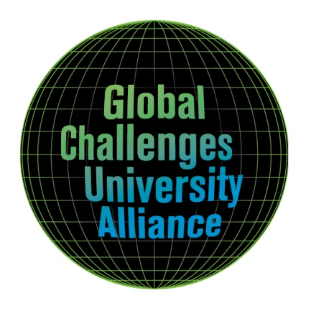

INVITATION TO THE
Global Challenges University Alliance (GCUA) Workshop, 16 - 18 April 2018, University of Natural Resources and Life Sciences, Vienna

Life Science Universities and the UN Sustainable Development Goals
The world is facing numerous and severe challenges. More than 800 million people globally live in extreme poverty and are facing hunger. More than half of the land used for agriculture is degraded thereby affecting 1.5 billion people globally. Climate change affects livelihoods all over the world and puts severe threats to survival in many areas. Inequity increases and causes losses of social coherence leading to an increase in conflicts and contributing to multiple crisis of democracy and governance. In order to address these multiple challenges, the resolution “Transforming our World: The 2030 Agenda for Sustainable Development” was adopted by the General Assembly of the United Nations in September 2015. The Sustainable Development Goals (SDGs) presented in this agenda break new ground in several ways: probably the strongest paradigm shift is that they are valid for all countries. This reflects a diffusion of “old” boundaries between the Global South which is to be developed and the global North which sets the model for development. It acknowledges new but often prominent boundaries between both, rich and poor countries but also and increasingly between rich and poor fractions of society within countries. The SDGs are also highly encompassing in their 17 goals and 169 targets which are structured along the broad topics of People, Planet, Prosperity, Peace and Partnership.
The preamble to the UN resolution states that “all countries and all stakeholders, acting in collaborative partnership, will implement this plan.” In this context, universities are increasingly called upon to contribute to reaching the ambitious goals. Universities can take up this responsibility through activities in three interdependent fields of action: (a) drive and support political and societal transformation by direct interventions in the policy process (b) realise their mission “through education for sustainable development and sustainable lifestyles, human rights, gender equality, promotion of a culture of peace and non-violence, global citizenship and appreciation of cultural diversity and of culture’s contribution to sustainable development” (SDG target 4.7) and (c) promote coherence of the SDGs and support their implementation through research. Universities need to conceptualize this role beyond slight and cosmetic adjustments of their missions, their research proposals, their teaching activities and their evaluation criteria for achieving relevance in the crucial transformations required. In preparing for the workshop, a draft position paper on “The role of Universities in achieving the SDGs” will be developed by a GCUA-SDG task force. It is the final aim of the workshop to finalise the position paper and set the stage for GCUA spearheading this process for Life Science Universities.

Workshop objectives
The workshop offers opportunities for sharing best practice examples in addressing the SDGs in political and societal action, in teaching and in research, for discussing the specific role of life science Universities for contributing to reaching the SDGs by their integration of socio-economic, ecological and technical aspects of land use and food chains and for sketching a way forward in fulfilling the claims of society.
With the workshop, we aim at (1) adopting a position paper of GCUA towards fulfilling the SDGs, (2) developing an agenda for research, teaching and management.
Workshop topics
- SDGs as societal and political mission for Universities
- SDGs as mission for Universities in education for sustainable development in the future
- SDGs as mission in research – address contradictions, identify knowledge gaps and pathways to sustainability
Preparation at GCUA partner universities:
We suggest that in the preparation phase to the workshop all GCUA partners specifically address the SDGs in selected teaching activities at all levels, e.g. seminars, case study projects, theses, so that the results from these courses can be presented and discussed during the workshop.

Participation and registration
If participation at this workshop is of interest, we would appreciate if you could encourage selected scientists at your university to register.
A maximum of 2 participants from each university are welcome to register for the workshop
BOKU will cover all workshop costs, meals and hotel for max. 3 nights for GCUA participants (1-2 scientists per invited university, up to a maximum of 40 participants on a first-come-first served basis) but not their travel costs.
So in brief, we would welcome 1-2 scientists of your university with expertise in the research areas specified above.
Online registration will be from open Mid January to March 1st, 2018 at https://www.slu.se/en/collaboration/international/global-challenges-university-alliance/ - in case of problems, please send an e-mail to gcua2018@boku.ac.at

For information about the GCUA initiative, please contact the GCUA coordinator Ioannis Dimitriou jannis.dimitriou@slu.se
For questions concerning the workshop and registration, please contact: gcua2018@boku.ac.at
Organizing Committee for GCUA Workshop Life Science Universities and the UN Sustainable Development Goals: Georg Gratzer, Andreas Melcher, Andreas Muhar, Maria Wurzinger, Thomas Lindenthal, Margit Scherb, Margarita Calderón-Peter. More information at https://www.slu.se/en/collaboration/international/global-challenges-university-alliance/workshops/?submenu=open
Looking forward to future communications and hopefully meeting your representatives in Vienna!

